**Fundamental Analysis of ICICI Bank(On August 26 2024)**

1. **Purpose of this Report**

The primary purpose of this report is to conduct a comprehensive fundamental analysis of ICICI Bank. The analysis aims to evaluate the bank's financial health, market position, and future growth potential. This includes assessing its financial statements, industry dynamics, macroeconomic factors, and comparative performance with peers. The report will culminate in an informed investment recommendation based on these analyses.  
ICICI Bank demonstrates strong profitability, robust capital adequacy, and effective risk management. The bank has successfully leveraged its digital transformation initiatives, contributing to its competitive edge in the market. However, its high P/E and P/B ratios indicate that the stock may be overvalued compared to its intrinsic value. Additionally, while the bank has shown solid financial performance, certain aspects like over-reliance on retail finance and a lower EPS compared to peers require attention.  
Based on the analysis, ICICI Bank is currently overvalued in terms of its stock price relative to its intrinsic value. However, the bank's strong fundamentals, coupled with positive market sentiment and growth potential, suggest that it remains a solid long-term investment. Therefore, the recommendation is to **Hold** the stock, with a view to reassess as market conditions evolve.

**2. Understand the Business**

* **Company Overview:**

ICICI Bank is the second-largest private sector bank in India offering a diversified portfolio of financial products and services to retail, SME and corporate customers. The Bank has an extensive network of branches, ATMs and other touch-points. The ICICI group has presence in businesses like life and general insurance, housing finance, primary dealership, etc, through its subsidiaries and associates. The bank has diverse exposure to various industries. Top industries include services - Retail finance (39.8%), Services - finance (8.2%), Rural (6.2%), Wholesale (4.7%), Banks (4.6%), Electronics (3.9%) Crude petroleum (3.6%), Services – Non-Finance (3.5%), Infrastructure (3.1%) This is compared as a % of total exposure of the bank. The bank also has an international presence, with branches in the US (New York), Singapore, Bahrain, Hong Kong, Dubai International Finance Centre, South Africa, China, Offshore Banking Unit (OBU), and International Financial Services Centre (IFSC), along with representative offices in the US (Texas and California), UAE, Bangladesh, Malaysia, Nepal, and Indonesia.

* **Industry Analysis:**

The Indian banking industry is one of the largest and most important sectors in the economy, playing a crucial role in the financial intermediation process. The sector is broadly divided into public sector banks, private sector banks, foreign banks, regional rural banks, cooperative banks, and small finance banks.

1. **Industry Size and Growth:** The Indian banking sector has shown steady growth over the years, with total assets of the banks increasing significantly. As of 2023, the total assets of the Indian banking sector were estimated to be over ₹180 trillion, with an annual growth rate of around 10%. Private sector banks like ICICI Bank have seen faster growth compared to public sector banks, driven by better asset quality, innovation, and customer-centric approaches.
2. **Market Structure:** The market is dominated by public sector banks (PSBs) like State Bank of India (SBI), which hold about 60% of the total assets. However, private sector banks like ICICI Bank, HDFC Bank, and Axis Bank have been gaining market share due to their agility, better technology adoption, and focus on customer service.
3. **Key Trends and Developments:** Due to Digital Transformation, the Indian banking sector is undergoing a rapid digital transformation. The adoption of digital banking, mobile banking apps, and fintech innovations has become critical for banks to remain competitive. ICICI Bank has been a leader in this space, with its early adoption of digital banking platforms like I Mobile Pay and innovative services like WhatsApp banking.
4. **Regulatory Environment:** The Reserve Bank of India (RBI) regulates the banking sector, enforcing policies aimed at maintaining financial stability. The implementation of Basel III norms, which focus on strengthening capital requirements, and the emphasis on improving the quality of assets through the management of Non-Performing Assets (NPAs), have been significant regulatory developments. ICICI Bank has maintained a strong capital adequacy ratio, complying with these regulatory norms.
5. **Economic Impact:** The banking sector is closely tied to the broader economic environment. Factors like interest rates, inflation, and GDP growth directly influence the sector’s performance. The recent interest rate hikes by the RBI to combat inflation have impacted loan growth and profitability in the short term, but the long-term outlook remains positive with expected economic recovery and growth.

**3. Analyse Financial Statements**

* **Income Statement:** In last 10 years, the revenue and profit of the ICICI Bank is growing annually at a constant pace of 12% and 15% respectively. This growth is observable in its stock piece as it is also showing increase of 16% every year. Although, the expenses for the firm become doubled in last 5 years but it is easily explainable as the firm is expanding its business in various fields, and it is consistent with increase in revenue.
* **Balance Sheet:** As in last ten years, the current assets of the firm get tripled, the current liabilities also go up by almost three times. As per this industry natures, your current liabilities is greater than their current assets because as banks grows, it will accept more deposits which increases its liabilities but this not an alarming factor because as bank’s liabilities are increasing, it is also increasing its reserves at a good rate and overall its debt to equity ratio is around 6.45 which is quite normal for this industry.
* **Cash Flow Statement:** Cash coming from operating activities are standard, but we can see a huge dip in years 2022 and 2023 but it recovered in 2024. the reason of this dip was increasing interest rates to counter inflation (action taken by government of India to counter the inflation caused due to covid-19) and the expenses done by company to expand its operations. Cashflow from investment and financial activities are also standard which results in a positive Net cash flow in last five years except 2023. Here, a little concerning factor is a little overborrowing in 2023 but overall firm has a good positive cash generating system and maintain good liquidity. (as it has good amount of reserves.)

**4. Ratio Analysis**

* **Profitability Ratios:**
  1. ROE = 18.8% (very good)
  2. ROA 12M = 2.13% (ok)
  3. Net Profit Margin = 21.53% (very good)
* **Efficiency Ratios:**
  1. Cost-to-Income Ratio = 40.6(good)
  2. Asset Turnover Ratio = .05(good)
* **Liquidity Ratios:**
  1. Current Ratio = 1.57(fine but not up-to mark),
  2. Loan-to-Deposit Ratio = .76(good)
* **Valuation Ratios:**
  1. Price-to-Earnings (P/E) = 18.70(overvalued and high),
  2. Price-to-Book (P/B) = 3.30x (very high),
  3. Dividend Yield = 0.83%(good)
* **Industry Specific ratio:**
  1. Capital Adequacy Ratio - 16.03% (very good)
  2. Gross NPA - 2.30% (good)
  3. Net NPA - 0.44% (very good)
  4. CASA Ratio - 39.4% (good)

Through ratio analysis we see that ICICI bank have good financial ratios. IT have a very high profitability. It has a good cash management and good amount of liquidity to support its operations which are reflected in its liquidity ratio. Although, its PE ratio is high compared to its industry average, we cannot consider it as a negative point, as people have a high expectation for this bank that it will perform well in future. The percentage of non - performing assets are also low which represents how well the bank’s risk management is.

**5. SWOT Analysis**

* **Strengths:** ICICI Bank is well-positioned within the industry due to its strong digital capabilities, diversified product portfolio, and focus on customer service. Its ability to adapt to changing industry dynamics is very crucial in maintaining its competitive edge. The bank maintains a healthy Capital Adequacy Ratio (CAR), which provides a buffer against financial shocks and regulatory requirements, ensuring financial stability. It has an extensive network of branches and ATMs across India, which provides easy access to banking services for customers, especially in urban and semi-urban areas which make it a well – established brand and a strong customer base.
* **Weaknesses:** Around 40% of the revenue of ICICI Bank is generated by its retail finance. While retail banking is a strength, it also poses a risk if the segment faces downturns, such as reduced consumer spending or increased loan defaults during economic slowdowns. Further compared to some global banks, ICICI Bank’s presence in international markets is relatively limited, which could restrict its growth potential outside India.
* **Opportunities:** The increasing adoption of digital banking in India presents a significant opportunity for ICICI Bank to expand its customer base, reduce operational costs, and introduce innovative financial products. It can Form alliances with fintech companies, e-commerce platforms, and other technology-driven firms which help ICICI Bank expand its offerings and reach new customer segments. The expanding middle class and increasing urbanization in India present significant opportunities for growth in retail banking. ICICI Bank’s strong retail presence positions it well to capitalize on this trend to create a monopoly. The government’s push for infrastructure development and support for small and medium enterprises (SMEs) provides growth opportunities in corporate and SME banking. ICICI Bank’s focus on expanding its SME lending portfolio aligns with these opportunities. As India’s global economic influence grows, there are opportunities for Indian banks to expand their international operations. ICICI Bank, with its existing overseas branches and subsidiaries, is well-positioned to benefit from this trend.
* **Threats:** The Indian banking sector is highly competitive, with strong players in both the public and private sectors. This competition can pressure ICICI Bank’s margins and market share. The banking industry is subject to strict regulatory oversight, and any changes in regulations (e.g., capital requirements, lending norms) could impact ICICI Bank’s operations and profitability for example-Fluctuations in interest rates affected ICICI Bank’s net interest margin (NIM) and profitability as we seen in year 2023. Also, with the increased focus on digital banking, ICICI Bank faces heightened cybersecurity risks. A significant breach could harm the bank’s reputation and lead to financial losses.

**6. Management and Corporate Governance**

* 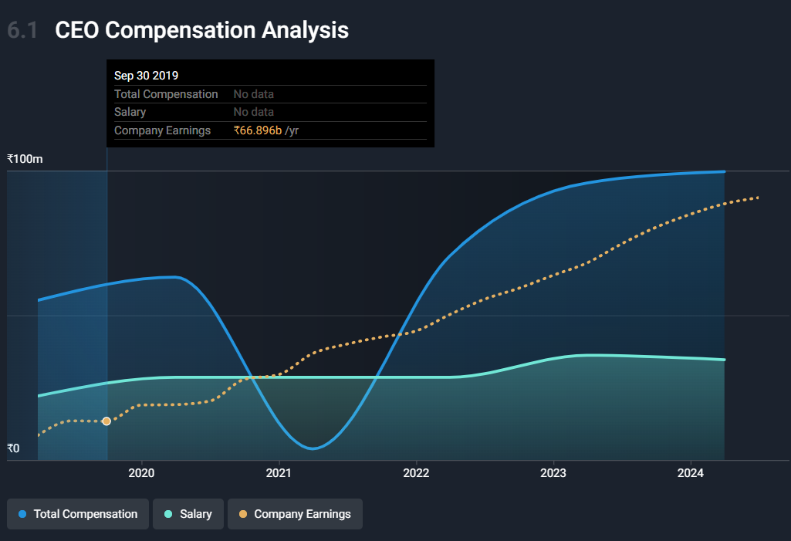ICICI Bank's CEO is Sandeep Bakhshi, appointed in Oct 2018, has a tenure of 5.83 years. total yearly compensation is ₹99.66M, comprised of 34.8% salary and 65.2% bonuses, including company stock and options, directly owns 0.005% of the company’s shares, worth ₹401.82M. Although, the overall pay for CEO Sandeep Bakhshi is 505% above the industry average, ICICI EPS grew by 30% over the past three years while total shareholder return over the past three years was 74%. Performance at ICICI Bank Limited has been reasonably good and CEO Sandeep Bakhshi has done a decent job of steering the company in the right direction. Also, CEO's compensation has been consistent with company performance over the past year.
* The average tenure of the management team and the board of directors is 3.9 years and 5.5 years respectively which are pretty good numbers.

**7. Economic and Market Conditions**

ICICI Bank's performance is directly depends to macroeconomic factors like interest rates, inflation, and GDP growth. An increase in interest rates generally boosts the bank’s net interest margins by allowing it to earn more on loans, although it may dampen loan demand. Conversely, lower interest rates can increase loan uptake but compress margins. Inflation can impact the bank by raising operational costs and heighten the risk of loan defaults, which could lead to higher non-performing assets (NPAs). As GDP growth is a critical driver of loan demand, a strong economy encourages borrowing and improves asset quality by reducing default risks. AS per current market conditions, including stock market trends and investor sentiment are highly positive and expecting greater returns. As positive trends can enhance the bank's stock price and facilitate capital raising, while negative sentiment could pose challenges, the current economic and market conditions are good for ICICI Bank's financial health and growth potential.

**8. Compare with Peers**

In this section, we are comparing ICICI Bank's financial metrics with its competitors, like HDFC Bank, SBI, and Axis Bank. This will give you a sense of how the bank is performing relative to its peers.

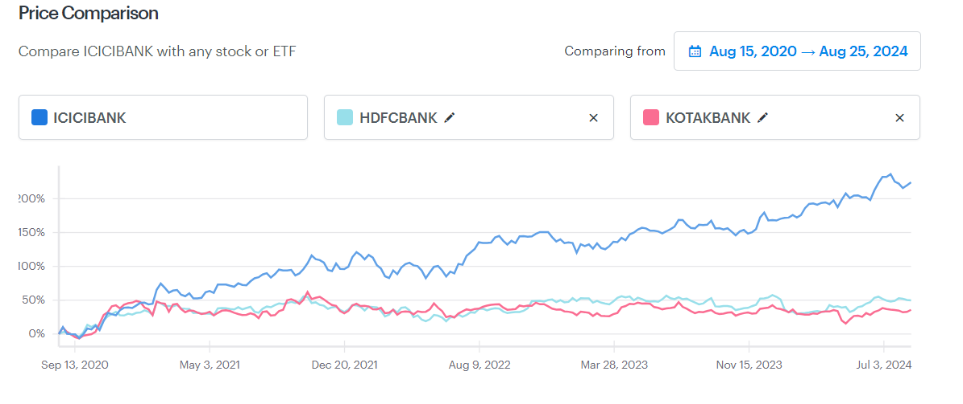First, we will see how the price of stock price is moving relative to its peers.

Here, as per above chat, we can conclude that increase in the stock price of ICICI bank compared to its peers are almost 4 times which shows a good investment opportunity. If we compare the volatility of the stock price of ICICI bank to its peers then we find that it is also lowest in its group. This is also a good investment sign.

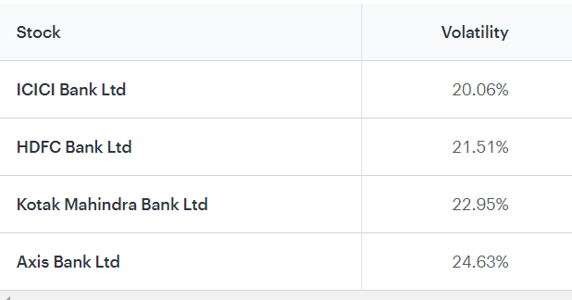

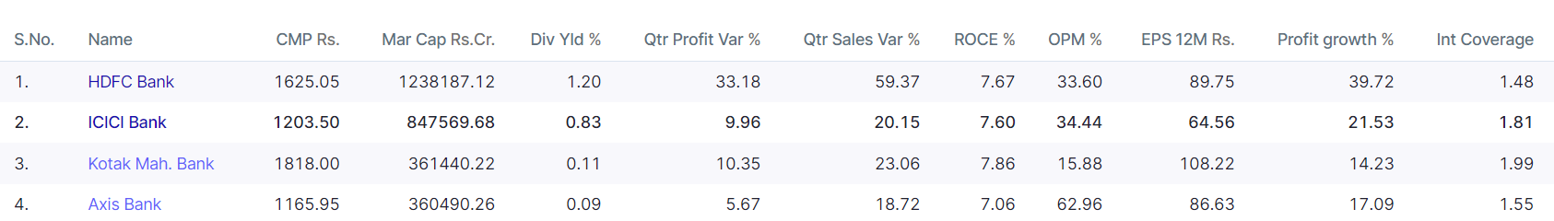Now, we are comparing some of the important financial ratios of ICICI bank to its peers and try to see how it is performing with related to its competitors.

Here, we can see that, although ICICI Quarterly sales and profits are a little less in compare to its peers but when we see the profit growth we observe that it has a veery good growth rate .its interest coverage ratio is also good in compare to its peer means it can easy give the interest payments for its debts(liabilities).Its dividend yield as also good but one thing which might be a little concerning is its EPS . It has lowest EPS value compare to its peers which may be due to its heavy reinvestment in recent years.

**9. Valuation**

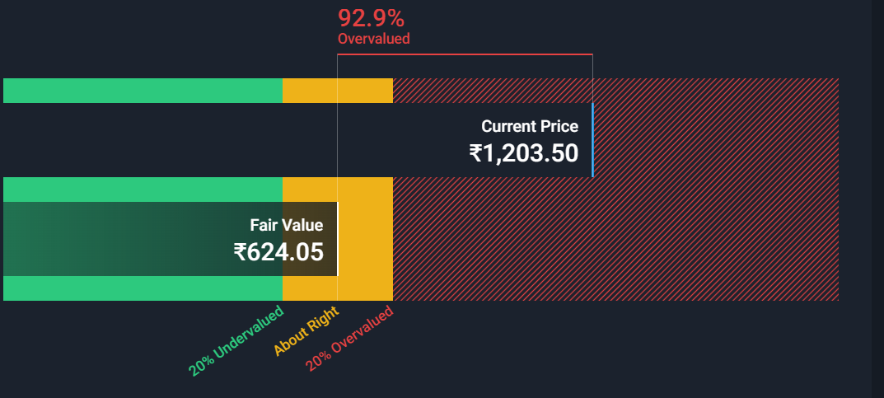We are using Discounted Cash Flow (DCF) valuation methods and Relative Valuation (P/E, P/B ratios) to estimate the intrinsic value of ICICI Bank's stock.

As we can see in the above, according to DCF analysis, the fair price of the ICICI stock should be around 625rs but currently it is almost double of it. So DCF analysis shows that its stock is highly overpriced to its fair value but this might not reflect the whole and true picture . Maybe market participatents sentiments are highly optimal for ICICI bank’s stock and they think that this firm have a good potential in future .

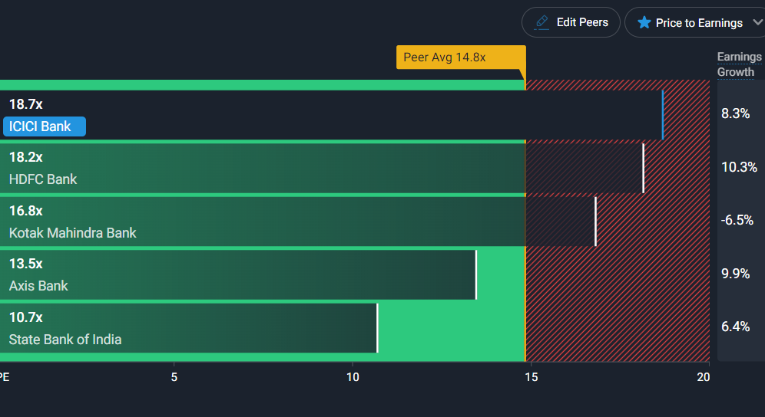To compare it with its peers , we will also use PE relative valuation technique to see where this firm’s stock stand in the market .

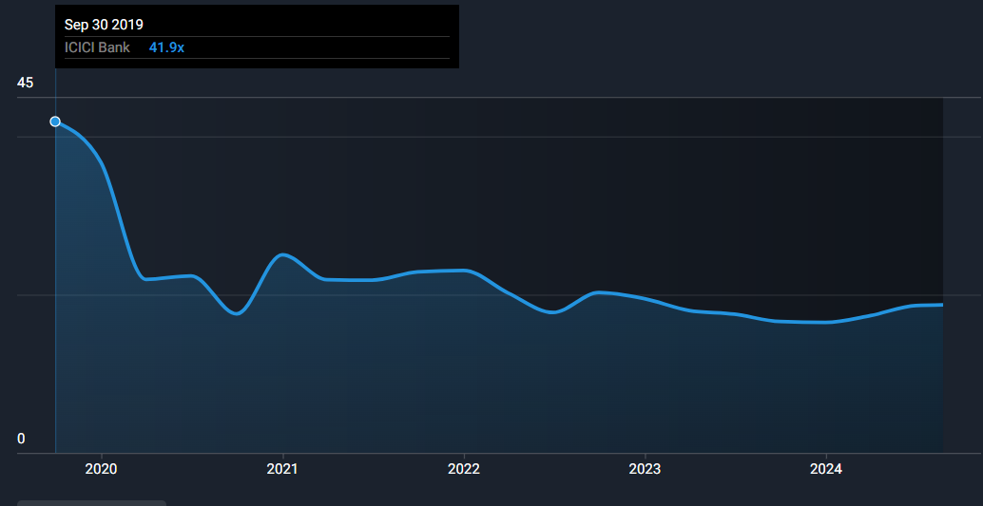As we can see that, ICICI bank’s PE ratio is much greater than market average also suggesting the overvalued case similar to DCF model but when we see this PE ratio in long run then we can see that, initially (around 2020) the bank’s PE ratio was too high and seen to be artificially inflated but with time is reduced. At first, it was 41.9x but after 2023 it is around 20x. This shows that people have a high expectation to this company

**10. Investment Thesis**

ICICI Bank's strong financial performance, robust capital adequacy, and leadership in digital banking position it well within the competitive Indian banking sector. The bank's diversified portfolio and focus on retail finance have contributed to its steady growth, although this concentration also presents risks if the retail segment faces economic challenges. The bank's stock appears overvalued based on both DCF analysis and relative valuation methods, yet the high P/E ratio reflects investor confidence in the bank's future growth prospects. While the bank’s international presence is limited, its focus on the growing Indian market and digital innovation provides a solid growth trajectory. Given the current market conditions and economic outlook, ICICI Bank is a sound investment for those looking for stability and moderate growth, making it a **Hold** at its current valuation. Long-term investors may benefit from retaining the stock, capitalizing on the bank’s potential to outperform in the evolving financial landscape.

**11. Conclusion**  
This report provides an in-depth fundamental analysis of ICICI Bank, covering its financial performance, industry standing, and macroeconomic influences. The analysis reveals that while ICICI Bank is fundamentally strong, with robust profitability and sound risk management, its stock is currently overvalued. Nevertheless, the bank’s strategic focus on digital banking and the growing Indian market supports a positive long-term outlook.

ICICI Bank, as the second-largest private sector bank in India, plays a crucial role in the financial sector. This report analysis the bank’s financial statements, industry position, and market conditions to provide a clear picture of its current standing and future potential. The purpose of this analysis is to inform an investment decision regarding ICICI Bank's stock. By this report, we thoroughly examine ICICI Bank’s income statement, balance sheet, and cash flow statement, alongside a detailed ratio analysis. A SWOT analysis highlights the bank’s strengths, such as its strong digital capabilities and capital adequacy, while also identifying potential weaknesses and threats, such as over-reliance on retail finance and regulatory risks. The management and corporate governance are evaluated, showing a stable leadership team that aligns compensation with performance. The report also compares ICICI Bank with its peers and conducts a valuation analysis using DCF and relative valuation methods, revealing that the stock is currently overvalued.

In conclusion, ICICI Bank is a well-established player with strong fundamentals and a promising long-term outlook. However, the current overvaluation of its stock suggests that investors should adopt a cautious approach. The investment recommendation is to Hold the stock, with periodic reassessments based on evolving market conditions and the bank’s performance relative to its peers.

**12. Appendices**

The above graphs and data are taken form below websites and reports:

Screener.in

Tickertape.com

Smartlywallstr.com

Annual report of ICICI bank

Investmentpedia.com